Class: | Stream:
S. 2
Name ………………………………………………… ………….

Signature ……………………………………………………….

S.2 BIOLOGY
April 2022
2 hours

Uganda Certificate of Education
S.2 END OF TERM ASSESSMENT
1 hour 45 minutes
INSTRUCTIONS TO CANDIDATES:
This paper consists of 8 questions.
Answer ALL questions
You may use a pencil for any diagrams or graphs.
Do not use staples, paper clips, highlighters, and glue or correction fluid.
1

2

3

4

5

6

7

8

Total

- a) Draw a straight arrow to match the diagram of each tissue with its function and adaptation. One arrow should be drawn to only one box (05 marks)
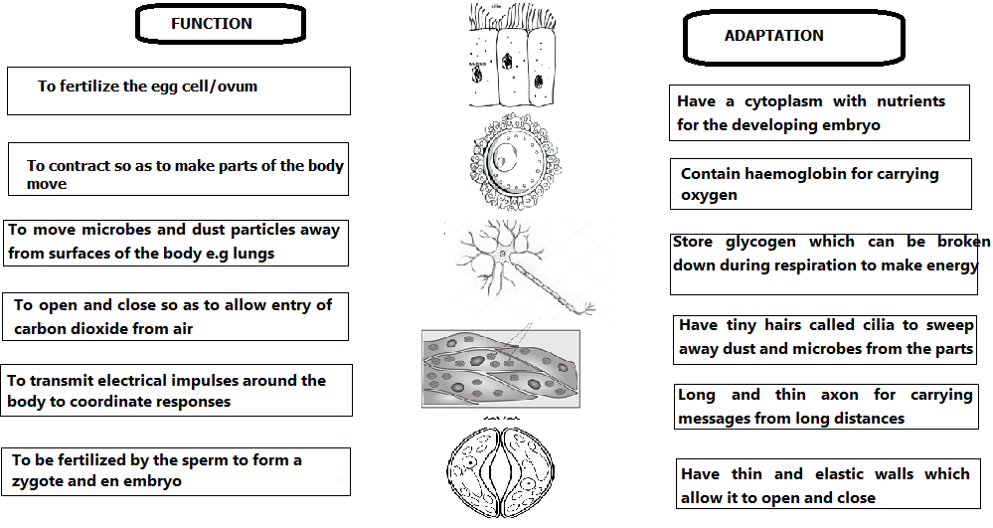
b) Leaves are regarded as organs, rather than tissues. Explain why a leaf is described as an organ, not a tissue
(02 marks)
………………………………………………………………………………………………………………………………………………………………………………………………………………………………………………………………………………………………………………………………………………………………………
c) Some of the cells above build up to form tissues, then organs and organ systems. State one organ systems in human body that is responsible for;
i) Transporting nutrients and respiratory gases around the body (01 mark)
……………………………………………………………………………………………………………………….
ii) Protecting the body against pathogens (01 mark)
………………………………………………………………………………………………………………………
iii) Producing hormones for chemical messages (01 mark)
………………………………………………………………………………………………………………………
- Viruses are responsible for several infections to living things including humans. In some ways, they are related to other living things and in other ways, they are different. Use the example in the diagram below to answer the questions that follow.
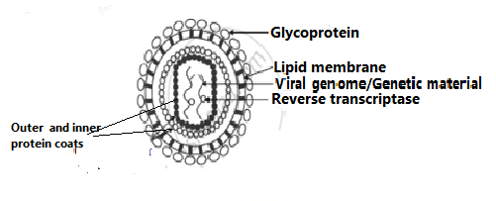
- What is the role of the following parts as shown in the diagram above; (02 marks)
- Lipid membrane …………………………………………………………………………………….
- Glycoprotein ………………………………………………………………………………………..
- Mention two ways in which; (02 marks)
Viruses are similar to other living things  - ………………………………………………………………………………………………  - ……………………………………………………………………………………………… | Viruses are different from other living things  - ………………………………………………………………………………………………….  - ………………………………………………………………………………………………………………………………………………………
- State any three viral diseases in animals that are transmitted by insects, and in each case, state the insect responsible for the viral disease (03 marks)
Viral disease | Insect that transmits the disease
- ……………………………………............... | ……………………………………………….
- …………………………………………………. | ………………………………………………..
- …………………………………………………… | ………………………………………………..

- Mentions two ways in which we can prevent common viral diseases (02 marks)
- …………………………………………………………………………………………………….
- …………………………………………………………………………………………………….
- Arthropods are very vital living things in nature. Below are some pictures of common arthropods in our environment.
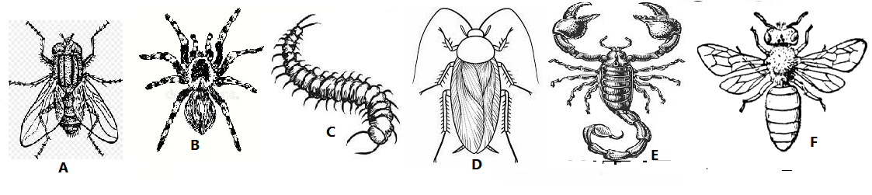

- Use the observable features on the drawings above to make an identification key for the arthropods A-F
(05 marks)
………………………………………………………………………………………………………………………………………………………………………………………………………………………………………………………………………………………………………………………………………………………………………………………………………………………………………………………………………………………………………………………………………………………………………………………………………………………………………………………………………………………………………………………………………………………………………………………………………………………………………………………………………………………………………………………………………………………………………………………………………………………………………………………………………………………………………………………………………………………………………………………………………………………………………………………………………………………………………………………………………………………………………………………………………………………………………………………………………………………………………………………………………………………………………………………………………………………………………………………………………………………………………………………………………………………………………………………………………………………………………………………………………………………………………………
- Animals A, D and F belong to the same group of living things. Mention three unique characteristics of the group of living things to which the living things belong (03 marks)
- …………………………………………………………………………………………………….
- …………………………………………………………………………………………………….
- …………………………………………………………………………………………………….
- State any two ways in which animal A is different from animal B (02 marks)
- …………………………………………………………………………………………………………………………………………………………………………………………………………………………………………
- …………………………………………………………………………………………………………………………………………………………………………………………………………………………………………
- Some plant parts perform functions which are quite different from those of the real parts of the plant. They are said to be modified. Use the following modified plant parts to answer the questions that follow
- Complete the table, by giving the required information (09 marks)
Modified part drawing | Name of modification | Function | Adaptation to function
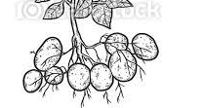
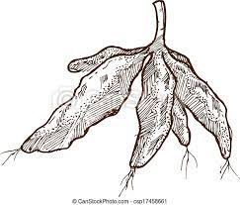
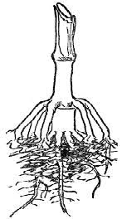

- What is the main function of roots to plants? (01 mark)
……………………………………………………………………………………………………………………
- The living things 1 and 2 belong to the same kingdom of living things.
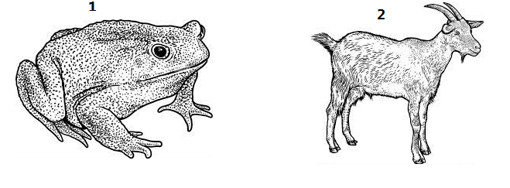
- Mention three characteristics that are only present in living things to which animals 1 and 2 belong
Animal 1 (1¹/₂ marks)
- …………………………………………………………………………………………………………
- ………………………………………………………………………………………………………
- ………………………………………………………………………………………………………….
Animal 2 (1¹/₂ marks)
- …………………………………………………………………………………………………………
- …………………………………………………………………………………………………………
- ………………………………………………………………………………………………………….
- List three similarities and differences between the two living things 1 and 2 (03 mark)
Similarities
- ……………………………………………………………………………………………………….
- ………………………………………………………………………………………………………..
- ………………………………………………………………………………………………………..
Differences (03 mark)
Animal 1 | Animal 2

- Animal 1 cannot keep its body temperature constant. What name is given to such an animal? (01 mark)
……………………………………………………………………………………………………………………….
- Plants K and L are shown belong.
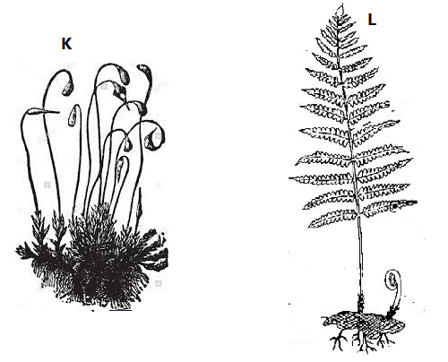
- Identify the phylum to which the plants K and L belong, and state two characteristics that each plant has so that it is classified in to the phylum you have mention (08 mark)
Characteristics
Phylum of plant K
……………………………………………………
Phylum of plant L
…………………………………………………….

- State two importance of plants to animals (02 mark)
- ……………………………………………………………………………………………………………….
- ……………………………………………………………………………………………………………….
- Insects are sometimes useful and in other ways harmful to other living things including humans.
- Match the following pictures to the correct description of methods of controlling harmful effects of insects by drawing an arrow (03 marks)
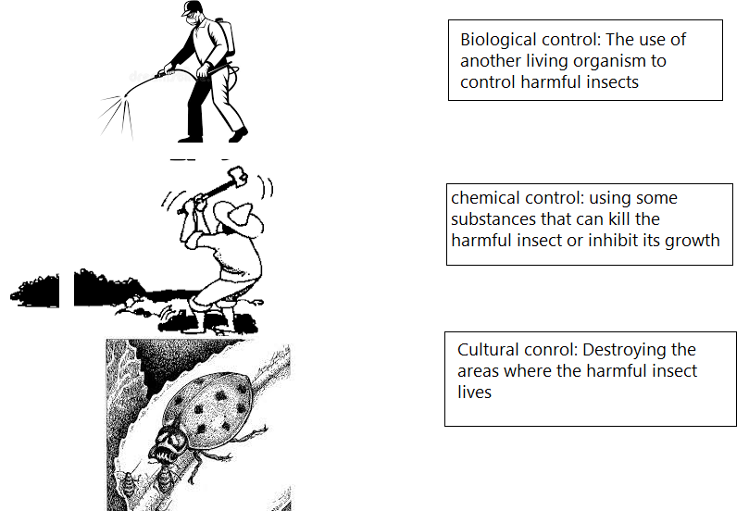
- Some of the methods stated in (a) above can harm the environment. Which of the above methods of pest control is the most suitable one? Give a reason for your answer (01 marks)
………………………………………………………………………………………………………………………………………………………………………………………………………………………………………………………………………………………………………………………………………………………………
- The table below shows some insects, which can be useful and sometimes harmful or even neutral. Mention two useful and one harmful effects of each of the insects (06 marks)

Insects | Useful effects (01 mark) | Harmful effects (01 marks)
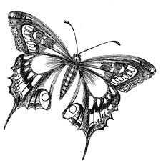 | ……………………………………….  ………………………………………  ………………………………………  ………………………………………
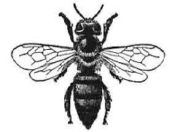 | ……………………………………….  ………………………………………  ………………………………………  ………………………………………
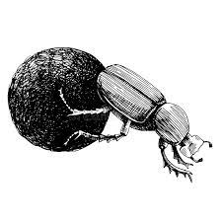 | ……………………………………….  ………………………………………  ………………………………………  ………………………………………

- The diagrams below are two cells.
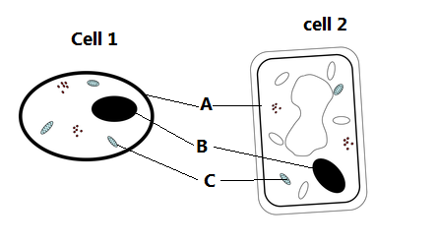
- Identify the cells 1 and 2 (02 marks)
Cell 1 …………………………………………….. Cell 2 ………………………………………………….
- Identify the parts labeled A, B and C and in each case, state their functions (03 marks)
Part A ……………………………………………. Function ……………………………………………….
Part B ……………………………………………… Function ………………………………………………
Part C ………………………………………………. Function ………………………………………………
- State two ways in which Cell 1 and cell 2 are similar and three ways in which they are different
Similarities
- …………………………………………………………………………………………..
- …………………………………………………………………………………………..
Differences
Cell 1 | Cell 2
- ………………………………….................. | - ……………………………………………………..
- ……………………………………………… | ii) ……………………………………………………..
- ……………………………………………….. | iii) ……………………………………………………….

END

